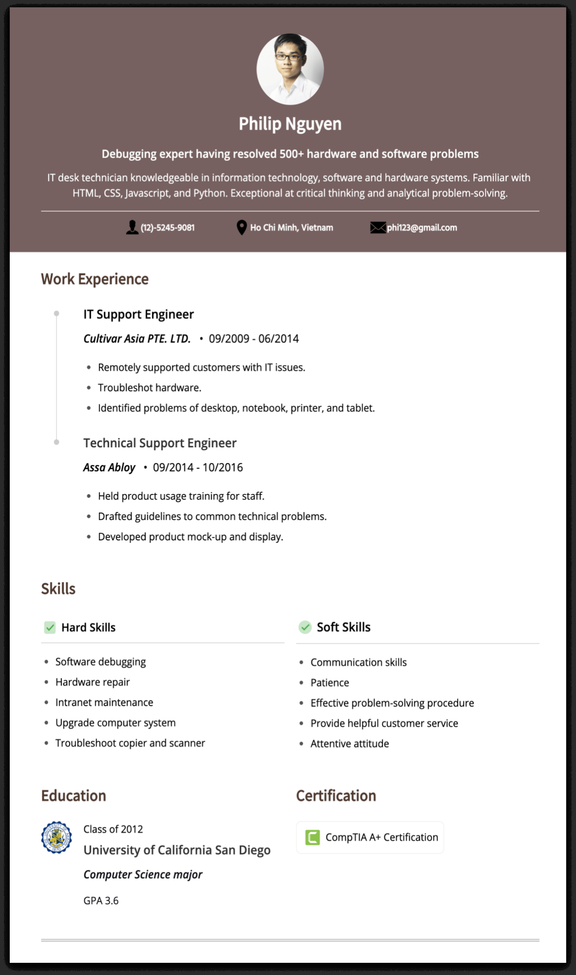
Philip Nguyen
Debugging expert having resolved 500+ hardware and software problems
IT desk technician knowledgeable in information technology, software and hardware systems. Familiar with HTML, CSS, Javascript, and Python. Exceptional at critical thinking and analytical problem-solving.
(12)-5245-9081
Ho Chi Minh, Vietnam
Work Experience
IT Support Engineer
Cultivar Asia PTE. LTD. 09/2009 - 06/2014
• Remotely supported customers with IT issues.
• Troubleshot hardware.
• Identified problems of desktop, notebook, printer, and tablet.
Technical Support Engineer
Assa Abloy
•
09/2014 10/2016
• Held product usage training for staff.
• Drafted guidelines to common technical problems.
•
Developed product mock-up and display.
phi123@gmail.com
Skills
Hard Skills
• Software debugging
• Hardware repair
• Intranet maintenance
•
Upgrade computer system
• Troubleshoot copier and scanner
Soft Skills
• Communication skills
• Patience
• Effective problem-solving procedure
• Provide helpful customer service
• Attentive attitude
Education
Class of 2012
University of California San Diego
Computer Science major
GPA 3.6
Certification
CompTIA A+ Certification

